Label the parts of plant and colour it-
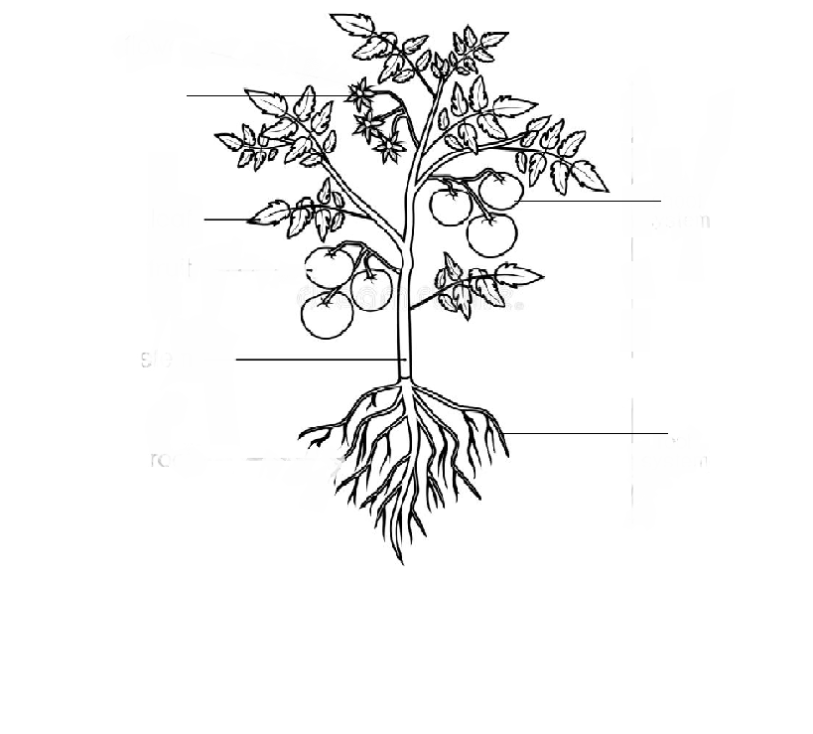
Circle the correct type of plant-
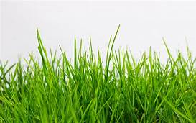 | Herb | Tree | Shrub
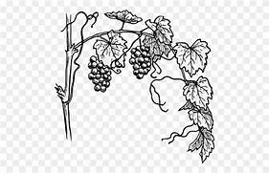 | Tree | Climber | Herb
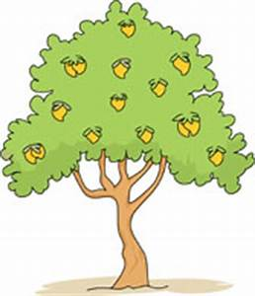 | Shrub | Herb | Tree
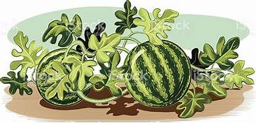 | Creeper | Climber | Herb

Tick the correct answer-

1) Wild animals live in-

(a) forests (b) park (c) home

2) Fish swim with the help of their-

(a) wings (b) fins (c)legs

3) Coconut is an-

(a) fruit (b) oilseed (c) flower

Fill in the blanks-

1) Banana is a ___________.

2) Spinach is a ___________.

3) Tiger is a________ animal.

4) Birds fly with __________.

